**MDF Rose Engine Lathe 2.0**

**with Stepper Motor Drive**

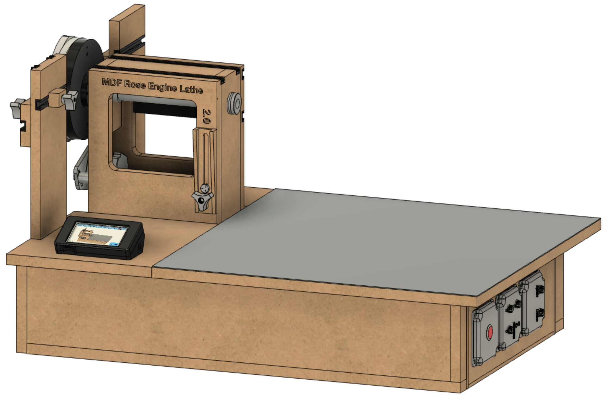

**Instructions for Building the**

**Stepper Controls**

**Version 0.4**

**17 August 2020**

This document is intended to help one unfamiliar with the MDF rose engine to build one easily. It is designed to go with the kit you can purchase from [www.ColvinTools.com](http://www.ColvinTools.com).

There are some variations from the ideas documented by Jon Magill at [www.rogueturner.com](http://www.rogueturner.com/). Where this is the case, we have tried to document such changes and provide the reason for the change.

This document is also designed to use a stepper motor for driving the spindle.

If you have any questions, please contact us at [ColvinTools@Gmail.com](mailto:ColvinTools@Gmail.com).

Good luck.

Rich Colvin & Jack Zimmel

Table of Contents

Getting Started 4

Cautions 4

Overview of Connections 5

Printed Circuit Board 7

Assembly of the Control Box Enclosure 11

Before Assembly 12

Assembly 14

Assembly of the Control Box Electronics 15

Parts List 15

Mounting Electronics to the MDF Base 16

Switch Settings 20

Assembly of the Nextion HMI Box 21

Parts List 21

Assembly of the Box 21

# Getting Started

As you get started with building this machine, please consider making the machine according to the outlined instructions. There are a boatload of ways you can modify this, and, quite frankly, the MDF rose engine encourages experimentation. But it is best to attempt those modifications after understanding how it works. Some ideas which sound grand may not appear so after understanding how the machine works (we speak from experience).

If you have any questions on the terminology in this document, check out the “Ornamental Turning Book of Knowledge” ([www.OTBoK.info](https://www.otbok.info/)).

This document outlines the approach for wiring this machine using:

* Rose Engine Controller Spindle and Three Axes V002c printed circuit board
* DM542T Stepper Motor Drivers
* Nextion 4.3” HMI Display, model NX4827K043

Standards are outlined in a companion document and are used for the compilation of this document.

## Cautions

1. **Do not perform any changes to this system when the system is powered on.** Power down and unplug the system before attempting any work.
2. If your local electrical code requires for any differences from what is documented here, those requirements take precedence over this document.
3. If you feel uncomfortable with anything in these instructions, consider having a licensed electrician perform the work.

**Please also note:** Permission is not granted to manufacture these for sale.

# Overview of Connections

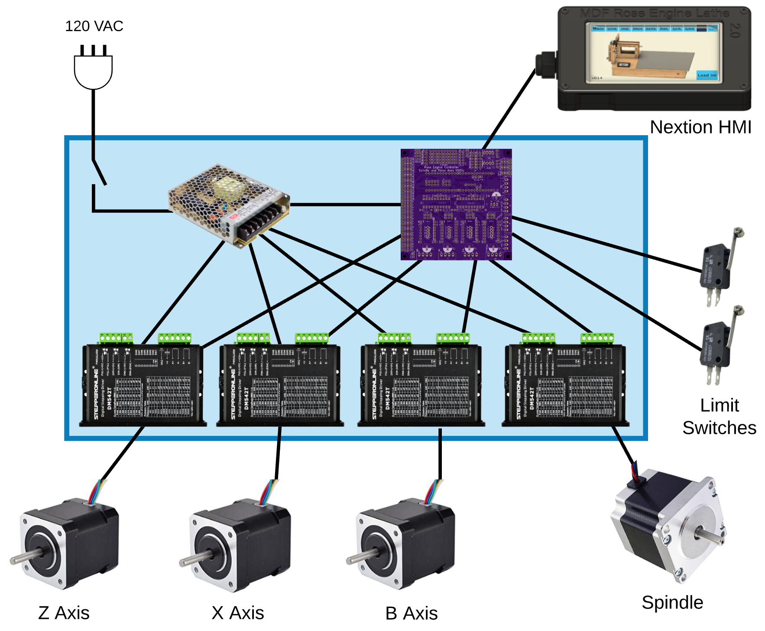

The whole system is shown in the picture below.

The system we supply with the MDF Rose Engine Lathe 2.0 Spindle Drive Option includes:

1. Everything in the Controls Box (the box in blue above)
   1. Power cord and on/off switch
   2. Power supply
   3. Printed Circuit Board with all components attached for 4 drives
   4. Stepper Motor Drivers (4 ea)
   5. Connectors for
      1. Nextion HMI
      2. 4 stepper motors
      3. 2 limit switches
2. Nextion HMI with connecting cable
3. Spindle stepper motor with connecting cable, attaching hardware, drive gears, and drive belt.

The other 3 stepper motors and the two limit switches (and associated attaching cables) are purchased separately.

Some have chosen to put the stepper motor controls in the lathe’s carcass, under the bed of the lathe. However, placing all the pieces together in a separate box gives these benefits:



**Figure 1- MDF Rose Engine Lathe 2.0 (B1 and B1A removed)**

1. This controls box is designed be placed under the bed in the MDF Rose Engine Lathe 2.0 (as shown in the picture to the right {the bed cover is removed}).

This approach also allows for the controls box to be used with the original MDF Rose Engine Lathe, just placing the box somewhere near the lathe.

This also frees up space under the bed for:

* 1. Storage of parts or tools, or
  2. Making a gap-bed lathe.

1. The many connections between the various pieces inside the box are already in place and the user does not have to figure out the correct alignment of connectors when building the MDF Rose Engine Lathe.
2. The connections to the stepper motors and limit switches are documented as standards. This allows for the creation of attachments (such as a curvilinear slide) with a built-in stepper motor and connecting it to the controls box.

The details for how we are building the one you can buy are below. These are documented for our use to ensure consistency, and we are publishing them for anyone who wishes to build their own.

The sequence of activities follows the layout of this document. That was done consciously. Changes to the sequence should be considered strongly before making changes.

# Printed Circuit Board

Attach the parts to the **Rose Engine Controller Spindle and Three Axes V002C** printed circuit board (PCB) using the instructions below.

### Parts List

Parts required for this section are below.

|  |  |  |  |  |
| --- | --- | --- | --- | --- |
| Item | Item | Qty | Source | Source P/N |
| 1 | Printed Circuit Board (PCB) | 1 | OSH Park | 4Rose_002c_Gerbers copy |
| 2 | Header Sockets | 1 | Digi-Key | HDR100IMP40F-G-V-TH-ND |
| 3 | 20-pin DIP sockets | 2 | Digi-Key | ED3054-5-ND |
| 4 | 10 KΩ resistors | 8 | Digi-Key | CF14JT10K0CT-ND |
| 5 | 100 µF electrolytic capacitor  (Mfgr p/n: KM101M050F115A) | 1 | LCSC | C59414 |
| 6 | 74HCT245 | 2 | Digi-Key | 296-1612-5-ND |
| 7 | R-78E5.0-1.0 | 1 | Digi-Key | 945-2201-ND |

### Through-Hole Components, part 1

Solder in the resistors as noted below.

10 KΩ resistors (8)

### Headers for Integrated Circuits

Solder in the 2 headers for the Teensy, and the 2 DIP sockets for the integrated circuits.

Headers (2) for Teensy 3.5

20-pin DIP sockets (2) for 74HCT245s

### Through-Hole Components, part 2

Solder in the components noted below.

100 µF Capacitor

R-78E5.0-1.0 DC DC Converter

### Cabling

Solder in the cables as noted below.

**Cabling for DM542T Drivers (4)**

(same for B, X, & Z)

|  |  |
| --- | --- |
| ⭘ GND | White |
| ⭘ DIR | Red |
| ⭘ STEP/PUL | Black |
| 🞎 ENA | Yellow |
| Enable is square & closest to the J6 / J31 / J32 / J33 label | |
| 20 AWG / 4 - Stranded | |

**Cabling for Nextion Display**

|  |  |
| --- | --- |
| ⭘ Tx | White/Orange |
| ⭘ Rx | White/Green |
| ⭘ GND | Orange |
| 🞎 +5V | Green |
| +5V is closest to the J20 label. | |
| Cat-5 or higher | |

**Cabling for 24 VDC Power Feed**

|  |  |
| --- | --- |
| ⭘ GND | White |
| ⭘ +24V | Red |
| 22 AWG / 2 | |

**Cabling for Limit Switches (2)**

|  |  |
| --- | --- |
| ⭘ GND | White |
| ⭘ +3.3V | Red |
| Pins 34 & 35 | |
| 22 AWG / 2 - Stranded | |

# A close up of a box Description automatically generatedAssembly of the Control Box Enclosure

The assembled box has

* A top and bottom made from ¾” MDF,
* Four sides made from ¼” MDF, and
* 4 corner posts made from quarter-round trim.

Removing the top reveals the box shown to the right.

The quarter-rounds are used to give the top and bottom something to set the spacing correctly.

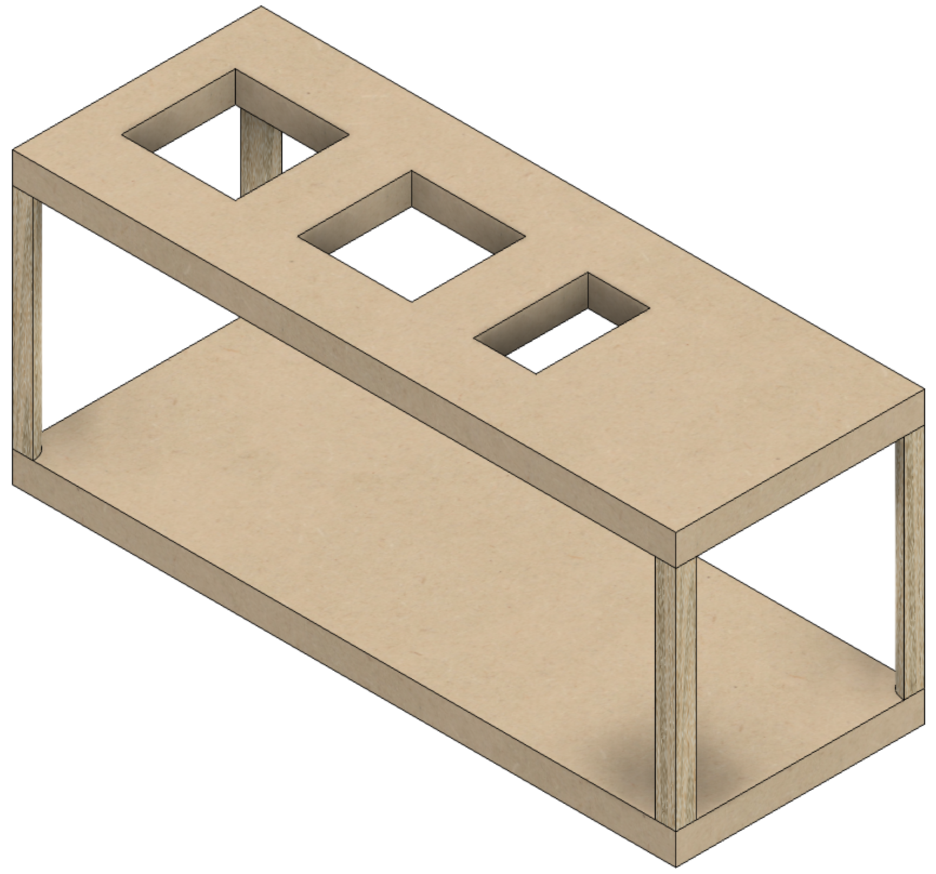The four ¼” thick sides are screwed to the top and bottom.

Replacing the top, and removing the sides reveals the view to the left.

## Before Assembly

The following instructions should be followed before assembling the controls box

### Bottom

This is made from ¾” MDF.

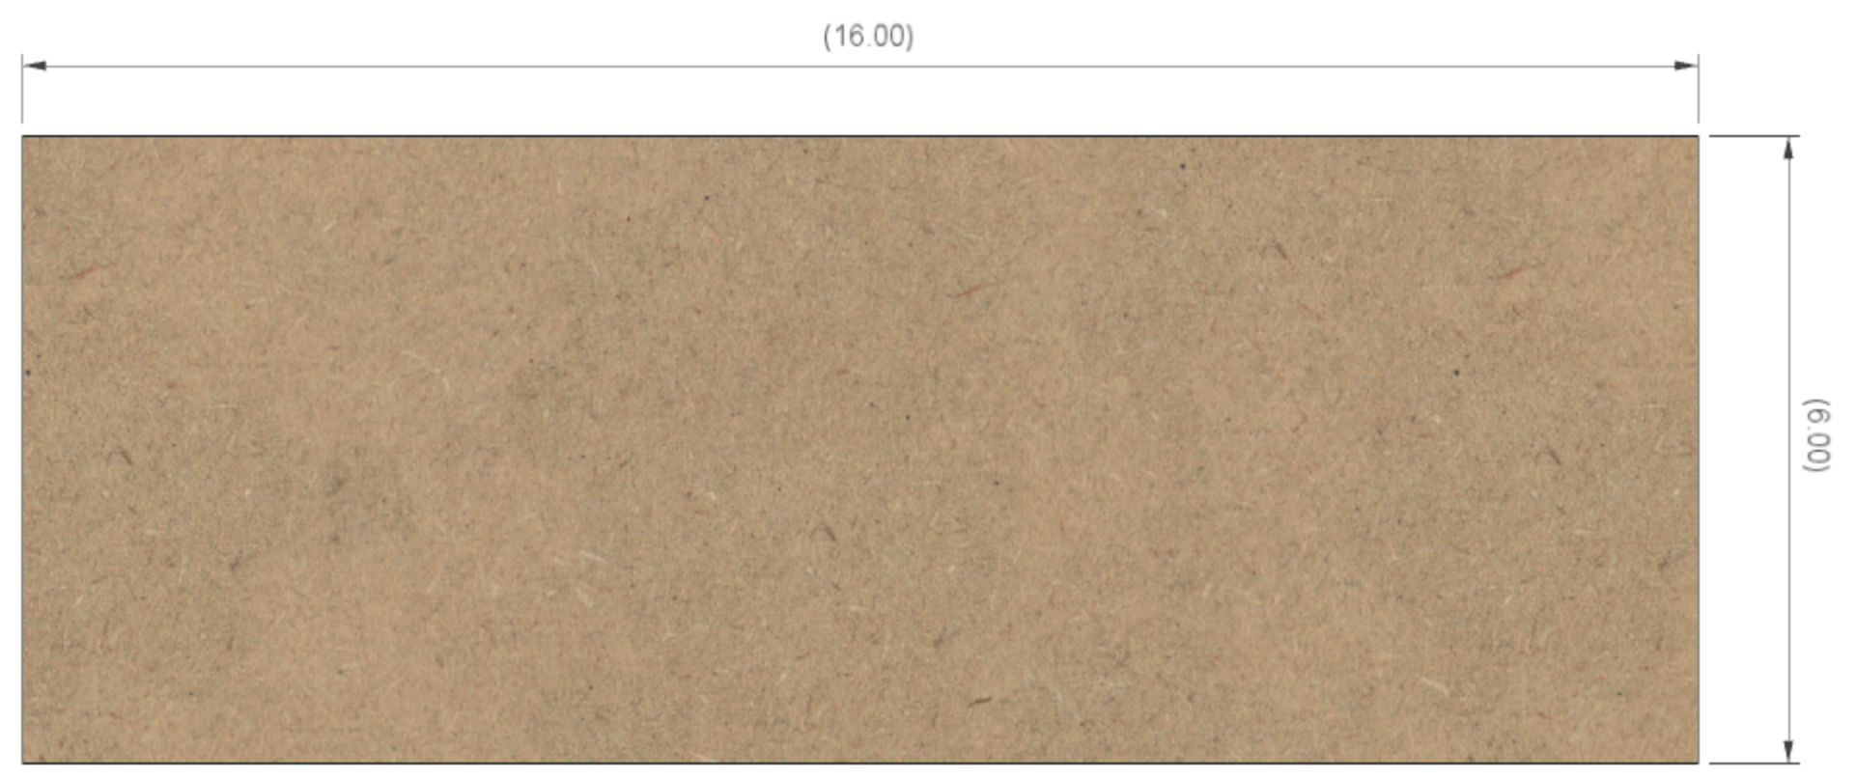

**6”**

**16”**

### Top

This is made from ¾” MDF.

**16”**

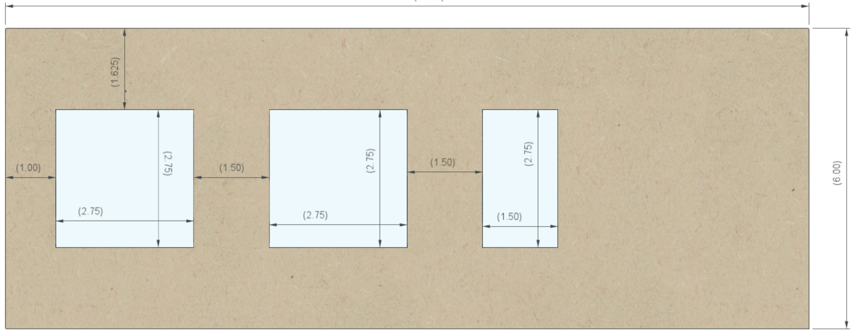

**1 ½”**

**1 ½”**

**1”**

**1 5/8”**

**1 ½”**

**2 ¾”**

**2 ¾”**

**2 ¾”**

**2 ¾”**

**2 ¾”**

**6”**

### A picture containing person, riding, standing, table Description automatically generatedShort Sides (2)

**6 ½”**

There are two of these, and they are made from ¼” MDF.

**7”**

### Long Sides (2)

There are two of these, and they are made from ¼” MDF.

**16”**

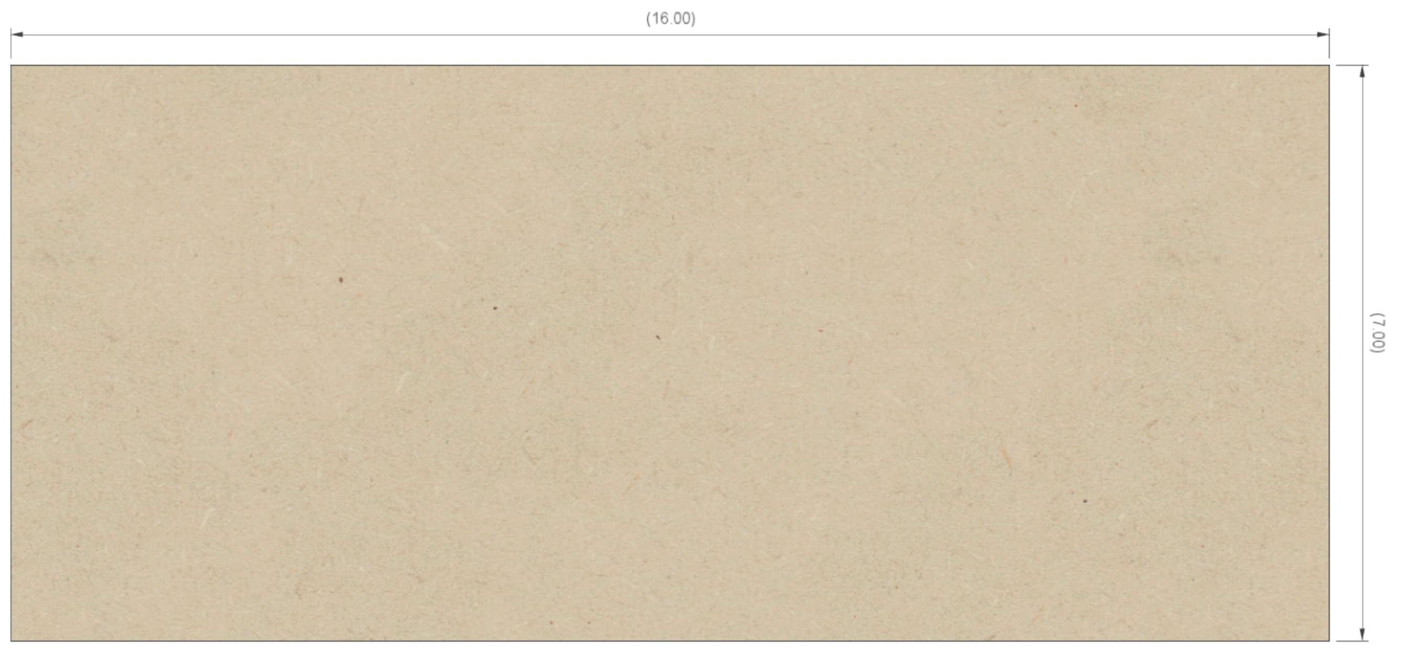

**7”**

### A picture containing sitting, monitor, television, dark Description automatically generatedQuarter Rounds (4)

**½”**

There are four of these, and they are made from any good trim material. These are ½” radius, but that is not terribly critical.

**5 ½”**

## Assembly

Glue the four quarter rounds to the ends of the two long sides. Be certain to:

1. center the quarter round so there is ¾” on each end, and
2. ensure the edges are flush to each other.

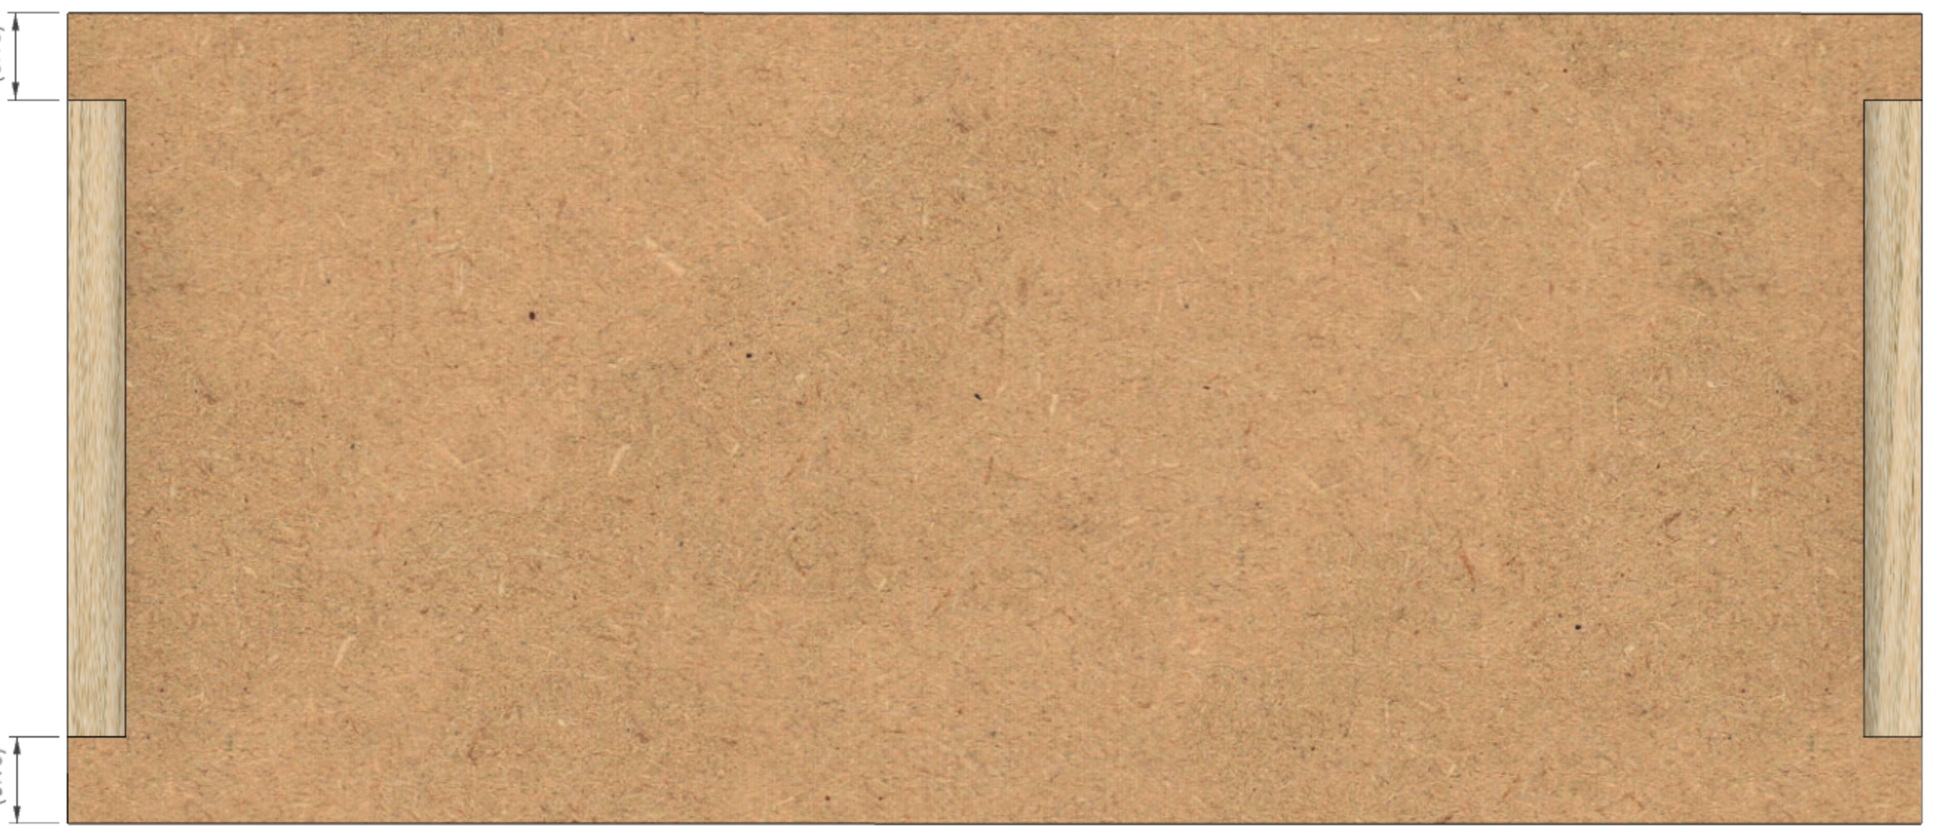

**¾”**

**¾”**

# Assembly of the Control Box Electronics

## Parts List

Parts required for this section are below.

### Items from Above

|  |  |  |  |  |
| --- | --- | --- | --- | --- |
| Item | Item | Qty | Source | Source P/N |
| 1 | Printed Circuit Board Assembly  (as outlined above) | 1 |  |  |
| 2 | Control Box Enclosure  (as outlined above) | 1 |  |  |

### Required Items

|  |  |  |  |  |
| --- | --- | --- | --- | --- |
| Item | Item | Qty | Source | Source P/N |
| 1 | AC/DC Power Supply - LRS-100-24 | 1 | Digi-Key | 1866-3314-ND |
| 2 | DM542T Stepper Driver | 4 | StepperOnline  or Amazon | DM542T |
| 3 | Utility box cover, 2 gang | 2 | Amazon | RACO 804C |
| 4 | GX-16/ 4 Male Socket | 4 | Amazon |  |
| 5 | Power Switch | 1 | Digi-Key | |  |  | | --- | --- | |  | 2216-SW19STM322-ND | |
| 6 | Terminal Block, 10 circuits | 1 | McMaster-Carr | ﻿7527K51 |
| 7 | QuickPort Wallplate – Single gang, 3 port | 1 | Amazon | Leviton 43080-1S3 |
| 8 | QuickPort Connector – RJ45 | 1 | Amazon | Levitron 5G108-AW5 |
| 9 | QuickPort Connector – 3.5mm Audio, Female | 2 | Amazon | Levitron 40839-SWS |
| 10 | Nylon Spacer (Unthreaded) for #8 screw – ¼” OD, ¼” length | 4 | McMaster-Carr | ﻿94639A293 |
| 11 | Cabling – CAT 5, 8” | 1 |  |  |
| 12 | Cabling – 20 AWG/4, 12” | 4 |  |  |
| 13 | Cabling – 20 or 22 AWG/2, 12” | 5 |  |  |
| 14 | Cabling – 20 or 22 AWG/2, 12” | 2 |  |  |
| 15 | Cabling – 16 AWG/3, 6 feet | 1 |  |  |

### Optional Items

|  |  |  |  |  |
| --- | --- | --- | --- | --- |
| Item | Item | Qty | Source | Source P/N |
| 1 | Micro SD Card Extender Cable (26”) | 1 | AdaFruit or  Digi-Key | 3688   |  |  | | --- | --- | |  | 1528-2523-ND | |

## Mounting Electronics to the MDF Base

Mount the electronics to the base piece of the MDF.

**LRS-100-24**

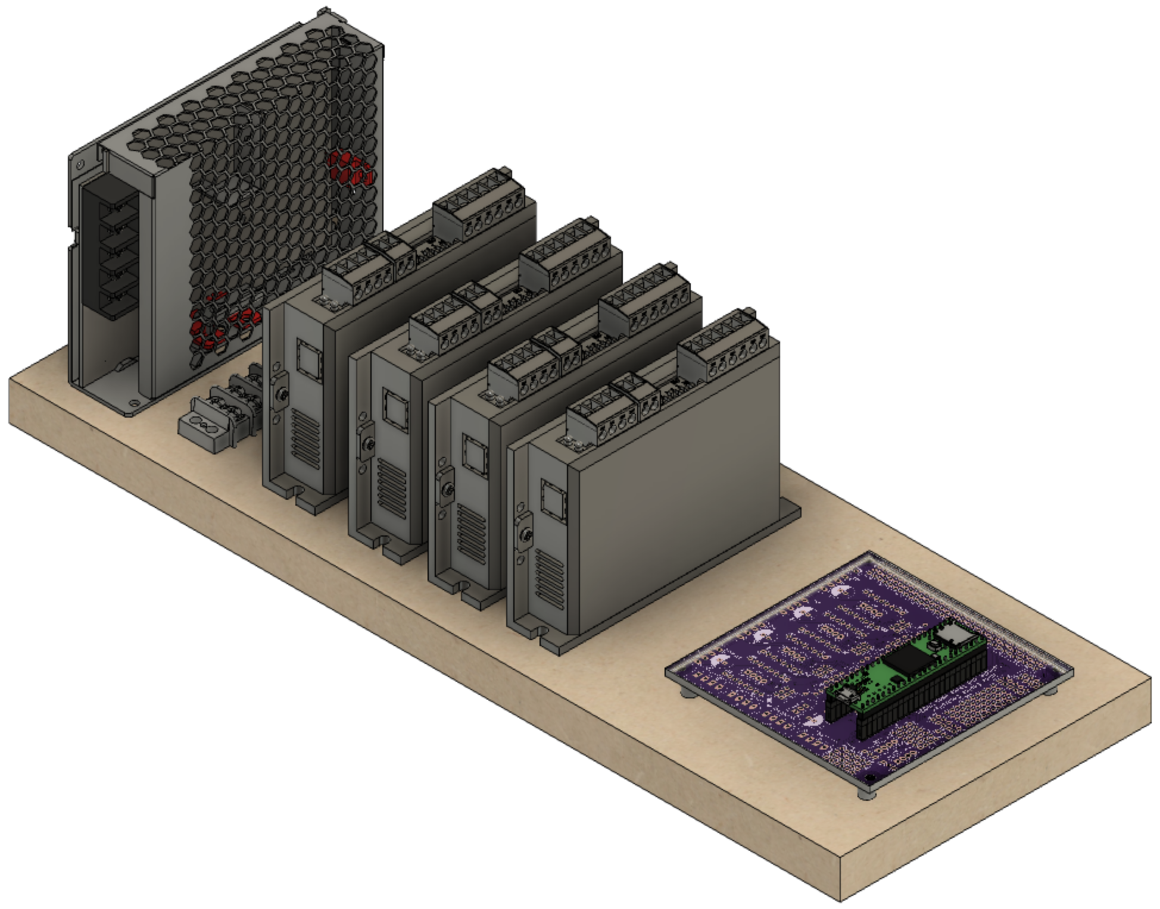

**PCB**

(sitting atop spacers)

**Terminal Block**

**DM542T – Spindle**

**DM542T – Z Axis**

**DM542T – X Axis**

**DM542T – B Axis**

### Wiring – Power Supply (LRS-100-24)

#### A picture containing honeycomb, food, oven Description automatically generatedPower Infeed

The power infeed is connected as:

|  |  |
| --- | --- |
| Wire Color | Power Switch |
| Black Incoming Power | Terminal 1 |
| Black Outgoing Power | Terminal 2 |

|  |  |
| --- | --- |
| Wire Color | LRS-100-24 |
| Black from Power Switch Terminal 2 | L |
| White | N |
| Green | GND (A picture containing drawing  Description automatically generated) |

|  |  |
| --- | --- |
| Conductor Type | Stranded copper |
| Conductor Size | 16 AWG (min) |
| Cable Size | 3 conductors / cable |

#### Power Outfeed

A terminal block is used to make the installation and maintenance of the system’s components easer. Using a terminal block allows connections to be added, changed, or removed without the risk of any other connections loosening.

|  |  |
| --- | --- |
| Conductor Type | Stranded or solid copper |
| Conductor Size | 20 or 22 AWG |
| Cable Size | 2 conductors / cable |

One of the power supply’s **+V** outfeeds, and one of the **-V** outfeeds is connected up to the terminal block where the power will be distributed.

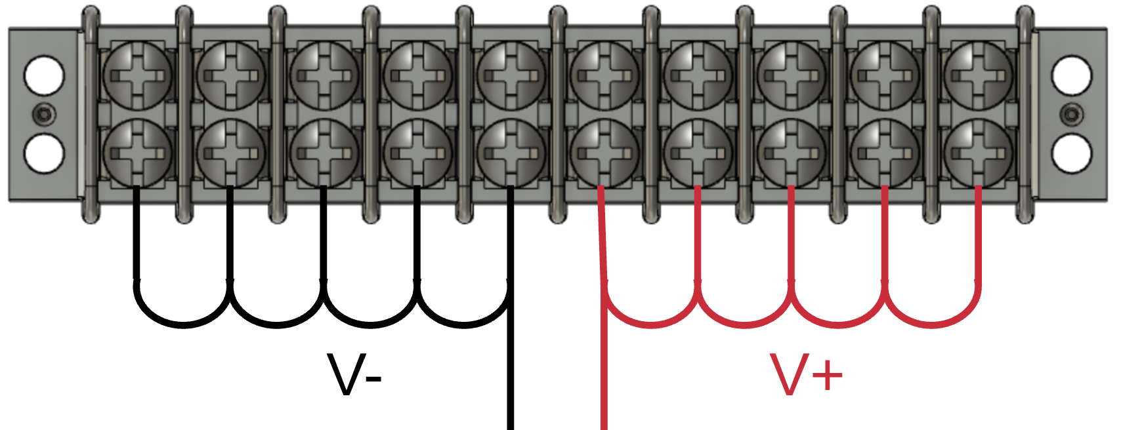

* **+V** is connected to one side of the terminal block using a red wire, and then that same colour wire is used to then cascade the +V side of the power to the next 4 terminals.
* **-V** is connected to the other side of the terminal block using a white or black wire. That same colour wire is then used to cascade the -V side of the power to the next 4 terminals.

### Power Wiring – Printed Circuit Board (PCB)

The PCB is connected to the terminal block for power. The cable from the PCB is already in place from earlier instructions in this document.

|  |  |  |
| --- | --- | --- |
| Terminal Block | Wire Color | PCB |
| +V terminal | Red | ⭘ +24V |
| -V terminal | White | ⭘ GND |

### Power Wiring – DM542T Stepper Motor Drivers (4)

Each of the 4 DM542T stepper motor drivers is connected to the terminal block for power.

|  |  |  |
| --- | --- | --- |
| Terminal Block | Wire Color | DM542T |
| +V terminal | Red | +V |
| -V terminal | White |  |

|  |  |
| --- | --- |
| Conductor Type | Stranded or solid copper |
| Conductor Size | 20 or 22 AWG |
| Cable Size | 2 conductors / cable |

### Signal Wiring – PCB to Stepper Motor Drivers (4)

Each of the 4 DM542T stepper motor drivers is connected to the PCB via 20 AWG/4 stranded wire. The cable from the PCB is already in place from earlier instructions in this document.

|  |  |  |
| --- | --- | --- |
| DM542T | Wire Color | PCB |
| Direction + | Red | ⭘ DIR |
| Direction - | White (GND) * | ⭘ GND |
| Enable + | Yellow | 🞎 ENA |
| Enable - | White (GND) * | ⭘ GND |
| Pulse + | Black | ⭘ STEP/PUL |
| Pulse - | White (GND) * | ⭘ GND |

* GND wires tied / bonded together.

### Signal Wiring – PCB to RJ-45 Jack for Nextion Display

The Nextion HMI is connected to the PCB via an RJ-45 connector. The cable from the PCB is already in place from earlier instructions in this document.

|  |  |  |
| --- | --- | --- |
| PCB | Wire Color | RJ-45 Pin |
| ⭘ Rx | White/Green | 1 |
| 🞎 +5V | Green | 2 |
| ⭘ Tx | White/Orange | 3 |
|  | Blue | 4 |
|  | White/Blue | 5 |
| ⭘ GND | Orange | 6 |
|  | White/Brown | 7 |
|  | Brown | 8 |

### Signal Wiring – PCB to 3.5mm Audio Jack for Limit Switches (2)

The two limit switches are connected to the PCB via a 3.5mm (1/8”) audio female jack. Pins 34 & 35 on the Teensy are used (one for each limit switch). The cable from the PCB is already in place from earlier instructions in this document.

|  |  |  |
| --- | --- | --- |
| PCB | Wire Color | Audio Jack |
| ⭘ +3.3V | Red | Tip |
| ⭘ GND | White | Sleeve |

### Signal Wiring –Stepper Motor Drivers to GX-16/4 Jacks (4)

Each of the 4 stepper motors is connected to the stepper motor drivers via GX-16/4 Jacks.

|  |  |  |
| --- | --- | --- |
| DM542T | Wire Color | GX-16/4 Pin |
| A+ | Black | 1 |
| A- | Yellow | 2 |
| B+ | Red | 3 |
| B- | White | 4 |

|  |  |
| --- | --- |
| Conductor Type | Stranded copper |
| Conductor Size | 20 AWG |
| Cable Size | 4 conductors / cable |

## Switch Settings

Set the switches on the DM542Ts as:



|  |  |  |  |
| --- | --- | --- | --- |
| Purpose | Set to | Switch | Setting |
| Current | 2.8A Peak  2.03A RMS | 1 | ON |
| 2 | ON |
| 3 | OFF |
| Half Current | 4 | OFF |
| Pulses / Rev | 6400 | 5 | OFF |
| 6 | ON |
| 7 | OFF |
| 8 | ON |

The current could be set higher with this driver; however, the selected NEMA 23 stepper motor does not need that so it is set thusly.

# Assembly of the Nextion HMI Box

## Parts List

Parts required for this section are below.

|  |  |  |  |  |
| --- | --- | --- | --- | --- |
| Item | Item | Qty | Source | Source P/N |
| 1 | Nextion 4.3” HMI Enhanced | 1 | ITEAD.cc | NX4827K043 |
| 2 | 3D Printed Enclosure | 1 | (self) | (see below) |
| 3 | Brass Heat-Set Inserts for Plastic, #4-40, 0.170” | 4 | McMaster-Carr | 94459A260 |
| 4 | Screws, #4-40, ¾” | 4 | McMaster-Carr | 97763A322 |
| 5 | M3 Screws, Thread Forming | 4 | McMaster-Carr | 96817A300 |
| 6 | Cord Grip | 1 | McMaster-Carr | 69915K47 |
| 7 | Cabling – CAT 5 or better, 36” |  |  |  |
| 8 | Magnets | 4 |  |  |
| 9 | (screws to attach magnets) | 4 |  | |  |  | | --- | --- | |  |  | |

## A screenshot of a computer screen Description automatically generatedAssembly of the Box

### Attach Nextion Display to the Bezel

One hole is printed into the back side of the bezel for attaching the Nextion HMI (circled in red to the right). That one needs to be enlarged using a #39 drill to a depth of 1/8”.

Attach one corner of the Nextion HMI using an M3 Thread Forming Screw, then center the HMI. Drill the other 3 corners, and then attach the display using the remaining M3 Thread Forming Screws.

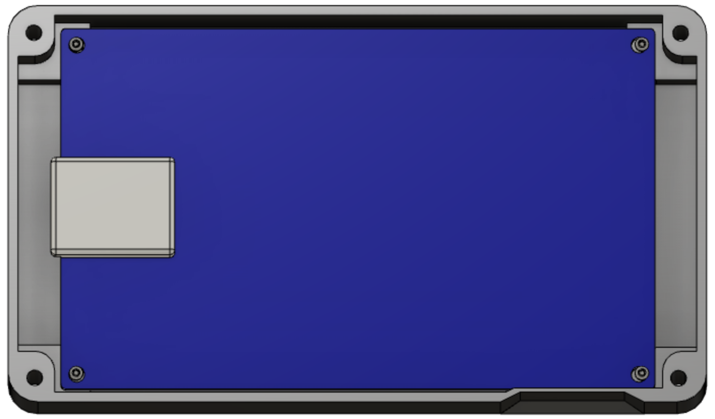

Note that the Nextion is inserted upside down. This is because the microSD card slot is then pointed down. And the microSD card slot is accessible so that upgrades can be done without having to disassemble the whole system. (The slot for inserting the microSD card is in the base, not the bezel.)

### A close up of a computer Description automatically generatedAttach Parts to the Base

Attach the 4 magnets to the base’s bottom. There are 4 insets in the base for these.

If the screws protrude into the base, take some efforts to grind or file those sharp points down.

### A picture containing sitting, electronic, monitor, oven Description automatically generatedInsert the Heat-Set Inserts

Using a heat gun, insert each of the heat-set inserts into the corners of the base.

### A picture containing indoor, sitting, table, monitor Description automatically generatedAdd Wire Cord Grip

The cord grip is used to ensure the signal wire does not pull against the Nextion display.

Depending on the printing, you may need to drill the whole with a ½” bit to ease the installation.

### Signal Wiring – PCB to RJ-45 Jack for Nextion Display

|  |  |  |  |  |
| --- | --- | --- | --- | --- |
| Nextion Connection | Nextion Wire Color |  | CAT 5  Wire Color | RJ-45 Pin |
| RX | Yellow |  | White/Green | 1 |
| +5V | Red |  | Green | 2 |
| TX | Blue |  | White/Orange | 3 |
|  |  |  | Blue | 4 |
|  |  |  | White/Blue | 5 |
| GND | Black |  | Orange | 6 |
|  |  |  | White/Brown | 7 |
|  |  |  | Brown | 8 |

The Nextion HMI is connected to the connection box via an RJ-45 connector. Using piece of CAT 5 (or greater) wire, 4 feet long, make the connections to the HMI’s connector (supplied by the vendor) as shown to the right.

Put a ¾” long piece of shrink file onto each one of the Nextion wires before connecting it to the CAT 5 wires.

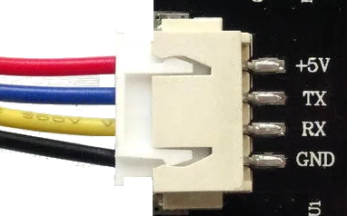



Connect the CAT 5 wire to the Nextion wires using a lineman’s splice (AKA, the Western Union splice, and shown to the right), and then solder the two together.

Heat the shrink file tubing around the joint to insulate it from the other things it could touch.

### Finishing It Up

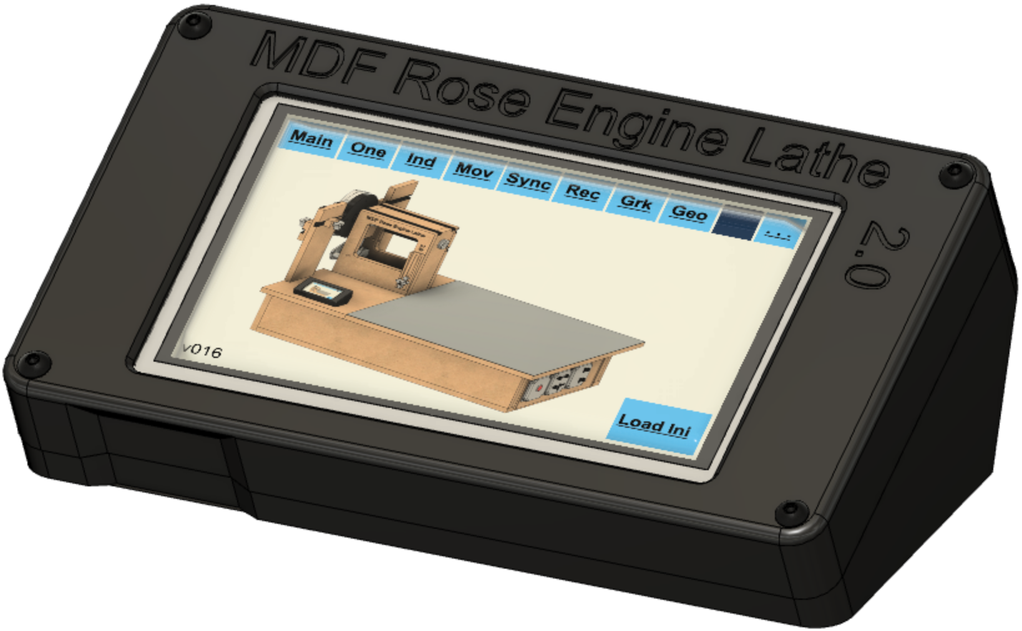Before screwing the bezel to the base, check to be sure everything works. If it works, screw the two pieces together using the four #4-40, ¾” long screws.

When finished and powered on, it will look like the picture to the right.

To the extent that material may appear to be infringed, we assert that such alleged infringement is permissible under fair use principles in U.S. copyright laws. If you believe material has been used in an unauthorized manner, please contact me at [ColvinTools@Gmail.com](mailto:ColvinTools@Gmail.com).

The layout of the Printed Circuit Board (PCB) is copyright Ed French and is used with his permission.

Permission is not granted to manufacture these for sale.